Making a Pitch bend wheel for the SK5, SK8 --- designed by Graham Meredith

Tools needed:

Small hobby drill or cordless drill, drill bits
Small file, suitable for plastic
Sandpaper
Hobby knife for cutting plastic

Materials needed:

40mm round black rubber door stopper
2"length of aluminium bracket, 1mm thickness, 20mm x 20mm or smaller
Hookup wire, insulated
Soldering iron, solder
Wire cutters
10k miniature potentiometer - example:
http://www1.jaycar.com.au/productView.asp?ID=RP8510&CATID=33&keywords=&SPECIAL=&form=CAT&ProdCodeOnly=&Keyword1=&Keyword2=&pageNumber=&priceMin=&priceMax=&SUBCATID=802

Procedure:

If you open up the SK 5 or 8, and look behind the power switch area, there is a vacant space above the lower circuit board. In this space, the lower circuit board is secured to the case by 2 screws, and there is a vacant slot beside it in the case:

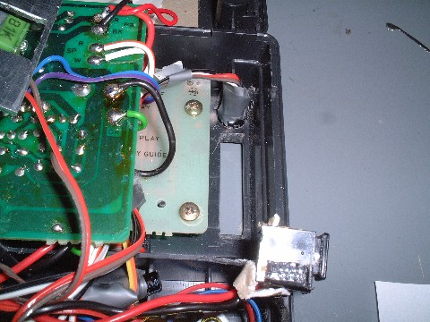

Remove these 2 screws.

Now put a 2" length of aluminium angle bracket over those 2 screw holes, mark their positions on the bracket. Remove the bracket and drill the holes in the bracket.

Now place the bracket in position over the holes on the circuit board, put the screws back in, securing both the bracket and the lower circuit board as originally designed. You now have the perfect mount for a volume pitch pot wheel!

Find the physically smallest pot you can buy, such as these or smaller:

http://www1.jaycar.com.au/productView.asp?ID=RP8510&CATID=33&keywords=&SPECIAL=&form=CAT&ProdCodeOnly=&Keyword1=&Keyword2=&pageNumber=&priceMin=&priceMax=&SUBCATID=802

Sit it on the bracket and mark where its shaft centre touches the vertical part of the bracket. Take the bracket out and drill out the pot shaft hole. I made a slot, rather than a hole, so I could accommodate different diameter wheels and mounting depths, as I experimented. I also cut out the bottom of the bracket, so I could get extra travel that I found I needed, with the pot that I chose.

Mount the pot, reinstall it and wire it up.

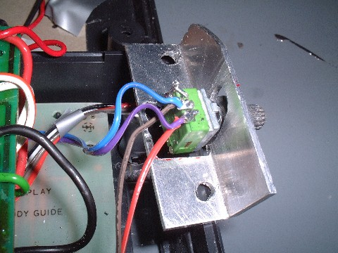

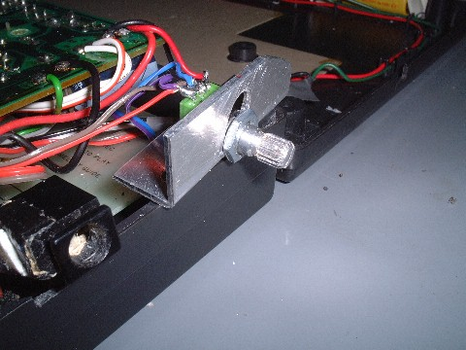

Find the largest diameter rubber door stopper you can find (commonly 38 mm). You can pick them up at any hardware store, but here is a link to some on-line:

http://www.amidata.es/componentes-electronicos-es/305771132-end-stops-door-furniture-rubber-end-stops.html

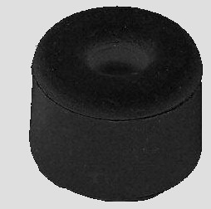

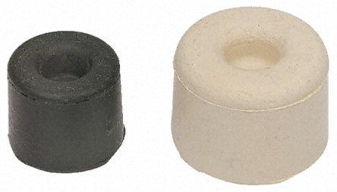

Using a sharp carving knife, slice a 1/4" thick wheel off it with the hole in the middle. You may have to take the slice from the back end of the stopper in order to get the smallest hole possible.

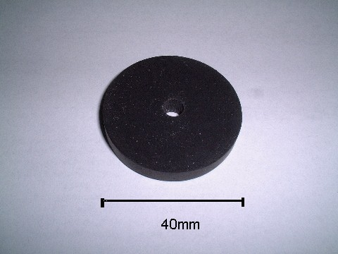

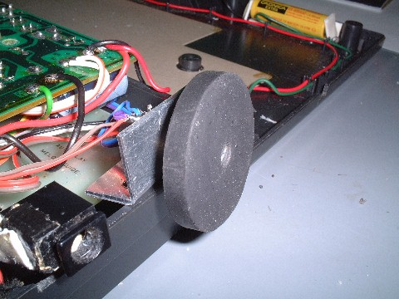

Mark inside the Casio case a slot for the wheel - make sure the pot assembly is installed, so you know that the wheel markings you make actually intersect the pot shaft and that when installed the wheel sits fully on the shaft for maximum grip, as well as being in the centre of the slot, and won't rub on the casing.

From the inside of the casing, gently drill 2 guide holes through the casing for the wheel - one each at the ends of the wheel slot. Now remove the pot and bracket so you can work on the slot from the outside of the case, without damaging the pot. Drill more holes along the slot length, then file out the plastic until you get a smooth slot that the wheel fits in.

Slot cut for wheel

Reinstall the pot, put the wheel on, and you're done! The larger the wheel, the better, but you will be limited by the size of the wheel you can have because it will rub against the back casing if it's too large. Mine is about 40mm diameter, and I still had a few mm spare room.

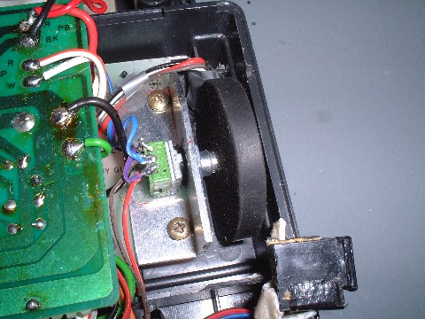

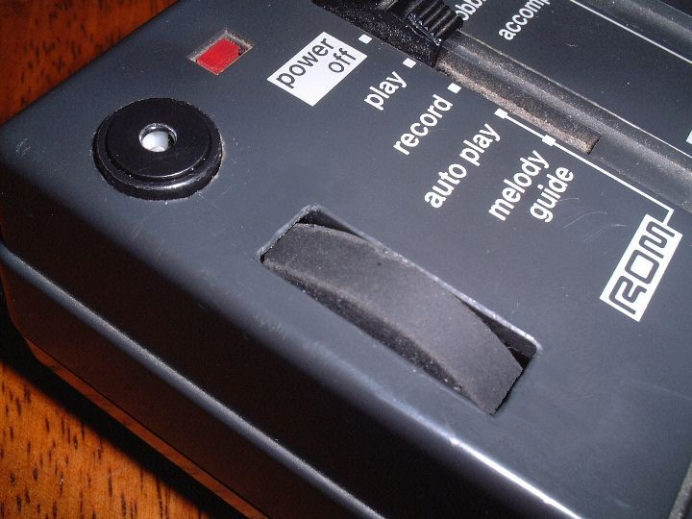

Finished!!

The pot can be connected to your favourite bend area for any use, but I connected mine to get instrument pitch bends (the bend instructions can be found also in the FILES section of the Yahoo Casio SK group).

Cheers, Graham

